Petit Nicholas:
(52 vidéos)

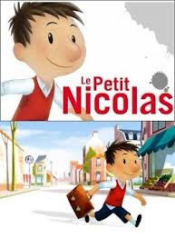

http://www.youtube.com/user/claudeluft/videos?view=0

French games:
http://www.french-games.net

Games:

http://www.interactivesites.weebly.com

